 |  | 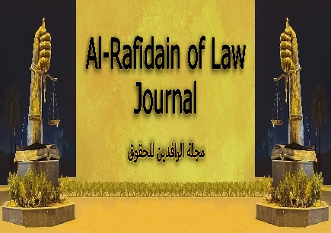
AL-rafidain of law Journal
Print ISSN: 1819-1746, Online ISSN: 2664-2778

ARLJ Cover letter
Month, Day, Year
Editorial Department Al-rafidain of Law Journal
University of Mosul
Mosul, Iraq

Dear Editor,
I am submitting a manuscript for consideration for publication in Al-rafidain of law Journal. The manuscript is entitled “Write the manuscript title here”. I confirmed that the manuscript has not been published elsewhere and that it has not been submitted simultaneously for publication elsewhere.
Also, the authors agree with the Publication Policy and Terms and Conditions of Al-rafidain of law Journal and confirm that they follow the Journal's instructions.

Thank you very much for your consideration.

Yours sincerely,

Corresponding author:
Name: ………………………………...
Affiliation: ……………………………
Phone no. with country code: ……….
E-mail: ………………………………..

